

Practices for Secure Software Report

Table of Contents
Document Revision History 3
Client 3
Instructions 3
Developer 4
1. Algorithm Cipher 4
2. Certificate Generation 4
3. Deploy Cipher 4
4. Secure Communications 4
5. Secondary Testing 4
6. Functional Testing 4
7. Summary 4
8. Industry Standard Best Practices 4

Document Revision History

Version | Date | Author | Comments
1.0 | 10/14/2026 | Avery Auvaa | Initial version

Client



Developer
Avery Auvaa

Algorithm Cipher
I selected SHA-256 as the cryptographic hashing algorithm for the checksum verification. SHA-256 is part of the SHA-2 family and produces a fixed-length 256-bit hash value regardless of the size of the original input. A hash function is one-way, meaning the resulting hash is intended to verify data integrity rather than be decrypted back into the original data. If the original data changes, even slightly, the resulting checksum will also change.
Unlike symmetric encryption, which uses the same secret key for encryption and decryption, and asymmetric encryption, which uses a public and private key pair, SHA-256 does not use encryption keys because it is a hashing algorithm. Random numbers are commonly used in cryptographic systems for purposes such as generating secure keys, initialization values, and salts, but they are not required for the basic SHA-256 checksum implemented in this application. For secure HTTPS communication, the application uses an RSA key pair contained in the generated certificate.
Cryptographic algorithms have evolved as older algorithms have become vulnerable to modern attacks. Algorithms such as MD5 and SHA-1 are no longer considered appropriate for security-sensitive hashing because weaknesses have been discovered that allow collisions. SHA-2 algorithms such as SHA-256 remain widely used for integrity verification. For Artemis Financial, SHA-256 provides an appropriate modern method for generating a checksum and detecting changes to transmitted data.

Certificate Generation
I generated a self-signed certificate using the Java keytool utility. I created an RSA key pair with a 2048-bit key size and stored it in a PKCS12 keystore named artemis.p12. The certificate was configured with identifying information and a validity period of 3,650 days. The keystore was then added to the application resources so that the Spring Boot application could use the certificate to enable HTTPS
secure communication. I also exported the self-signed certificate as an artemis.cer file to verify that the certificate was generated successfully.
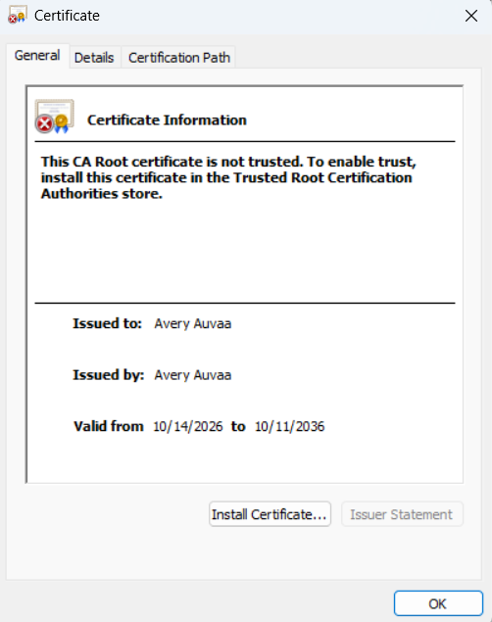
.

Deploy Cipher
I refactored the application to implement a SHA-256 cryptographic hash function using Java’s MessageDigest class. I created a /hash endpoint that hashes the unique data string “Avery Auvaa - Artemis Financial Secure Checksum.” The application converts the resulting hash bytes into a hexadecimal checksum and displays both the original data and checksum. This provides a method of verifying data integrity because any modification to the original data would produce a different checksum.
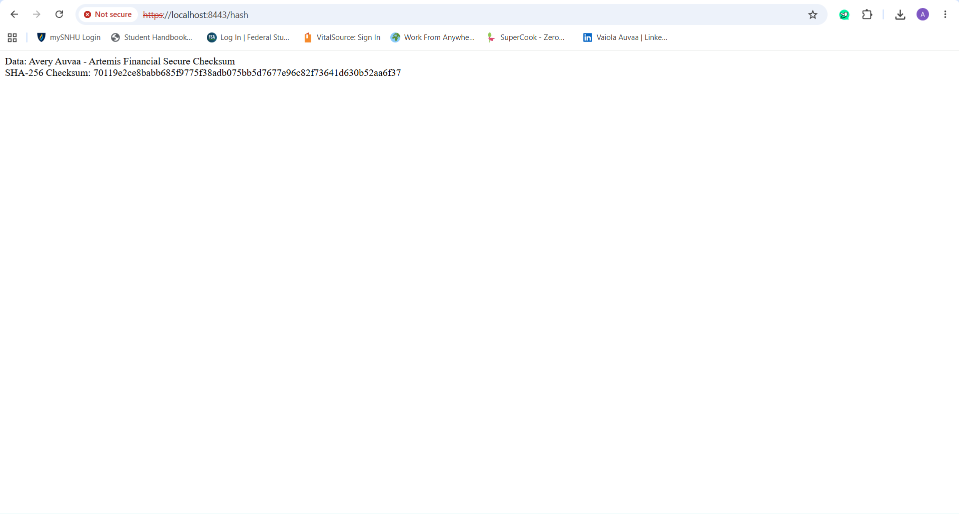

Secure Communications
I refactored the application configuration to use HTTPS instead of HTTP. I configured the Spring Boot server to use port 8443 and the PKCS12 keystore containing the self-signed certificate. The application was then compiled and executed, and I verified secure communication by accessing https://localhost:8443/hash in the browser. Because the certificate is self-signed rather than issued by a trusted certificate authority, the browser displays a certificate warning; however, the application is communicating through HTTPS on port 8443.

Secondary Testing
I performed secondary static testing on the refactored application using the OWASP Dependency-Check Maven plug-in. I updated the Dependency-Check plug-in and successfully completed the scan with a BUILD SUCCESS result. The generated report identified known vulnerabilities associated with dependencies already present in the provided code base. The security features I added for this project used Java’s existing security libraries and application configuration rather than introducing additional third-party application dependencies. I reviewed the results to verify that the refactoring did not introduce additional dependency vulnerabilities.
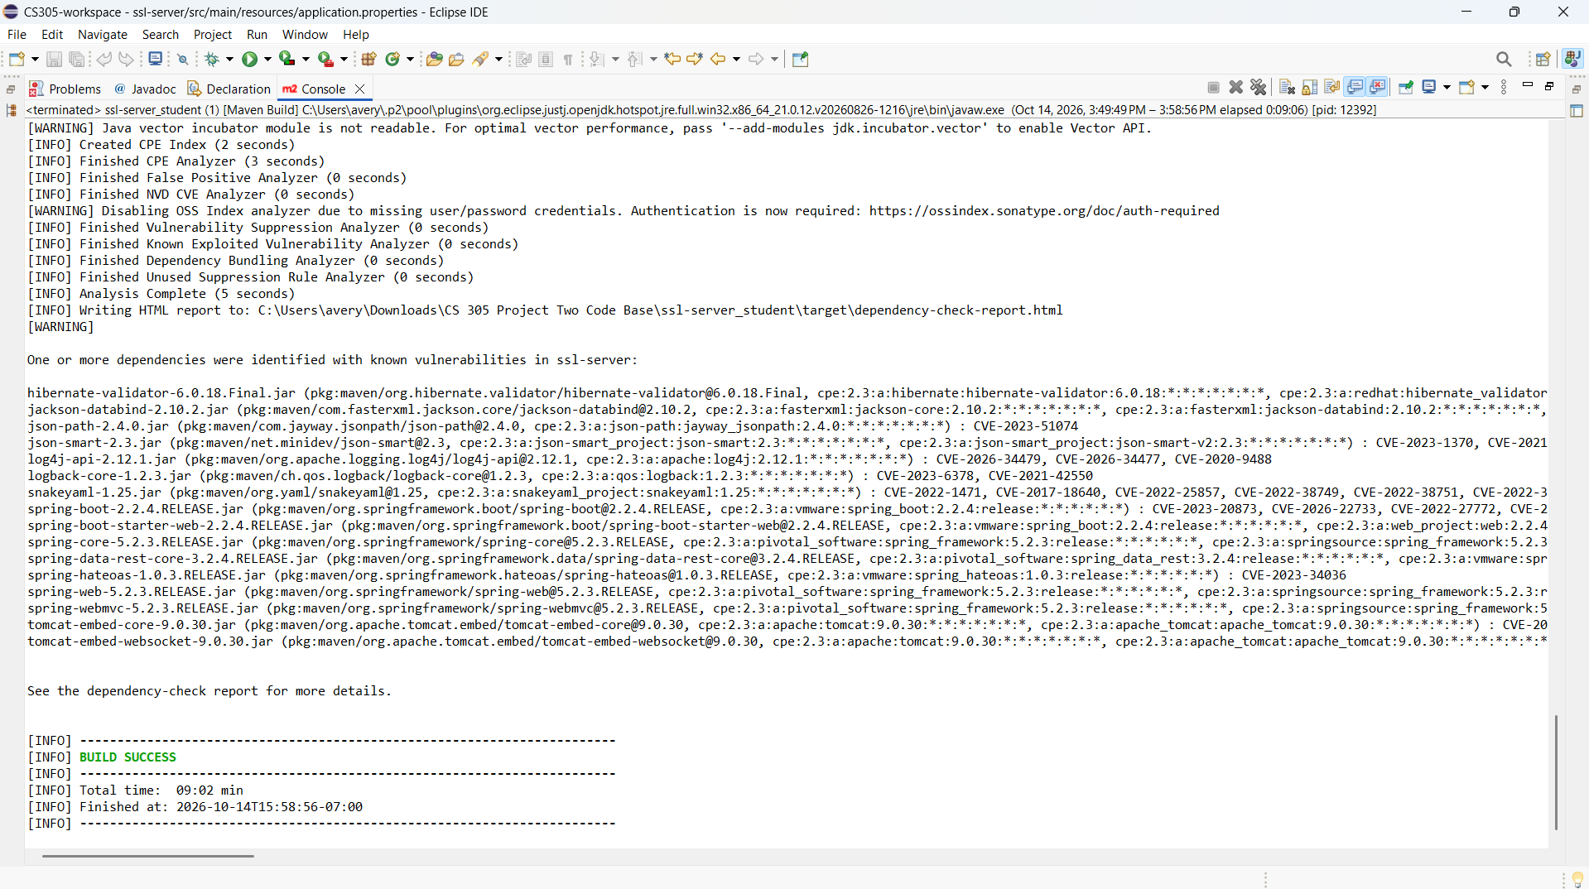
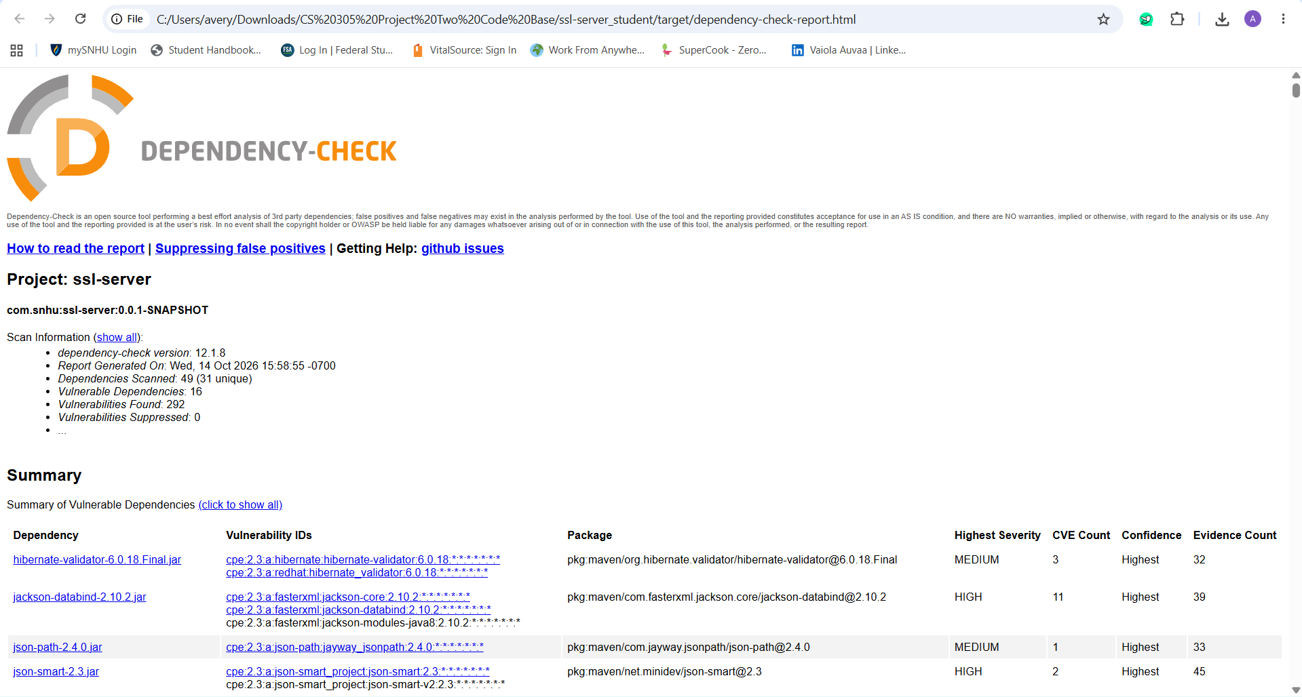

Functional Testing
I performed functional testing by manually reviewing the refactored application for syntactical, logical, and security issues. I verified that the SHA-256 checksum method compiled correctly, that the /hash endpoint returned the expected data and checksum, and that the HTTPS configuration correctly loaded the PKCS12 keystore. I then executed the application and confirmed that the Spring Boot server started successfully on HTTPS port 8443 without application errors. Finally, I accessed the /hash endpoint in the browser to verify that the application functioned as expected after the security changes.
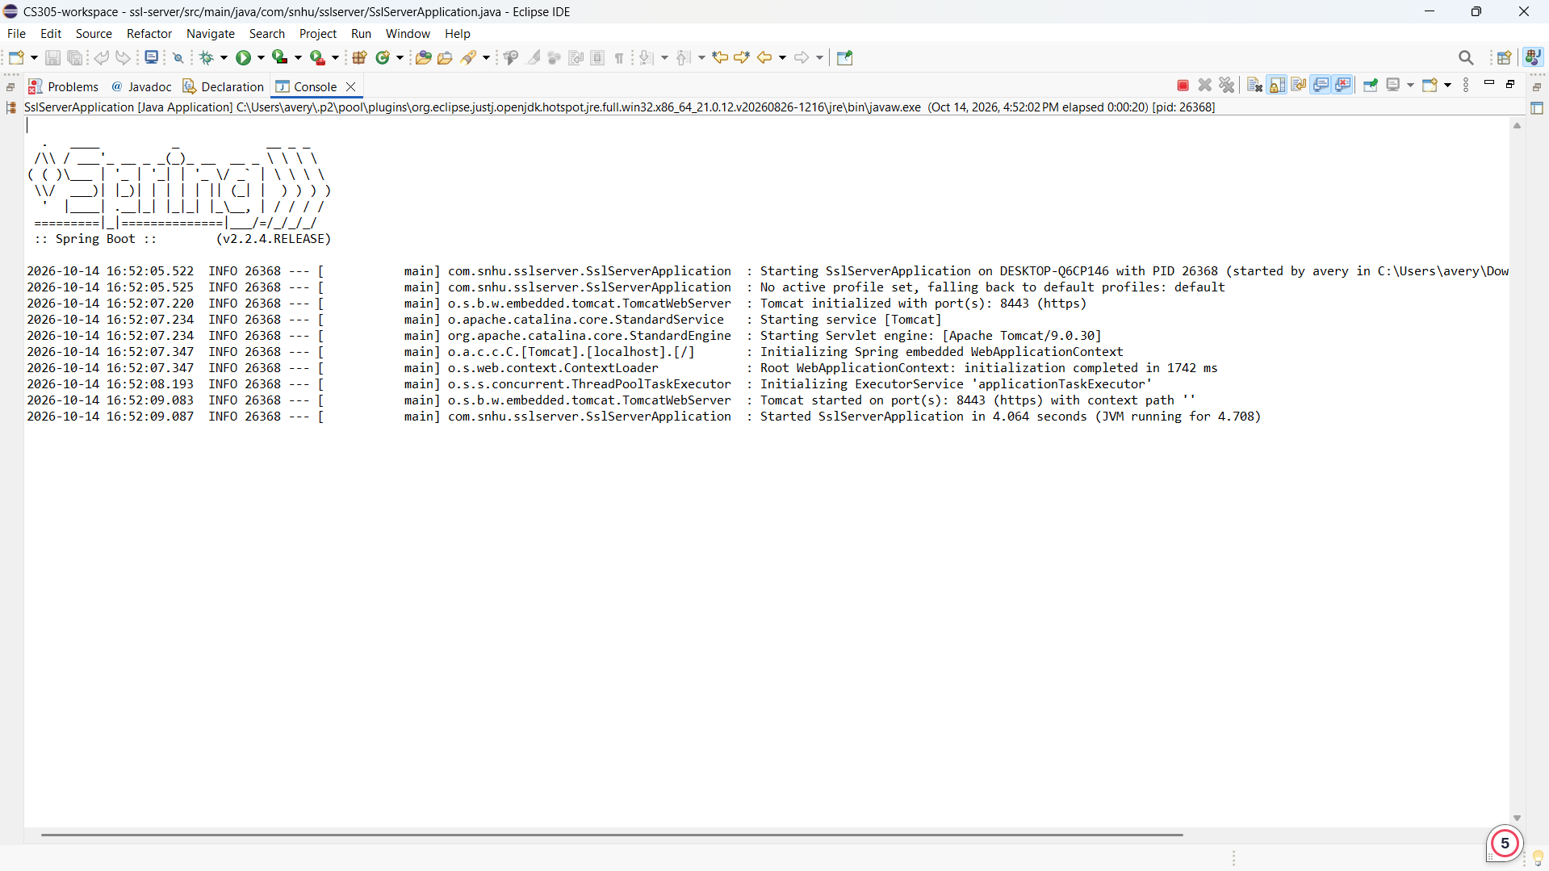

Summary

The security assessment and refactoring process improved several areas of security within the Artemis Financial application. Following the vulnerability assessment process flow, I addressed cryptography, secure communications, dependency analysis, and code quality. I implemented SHA-256 hashing to provide checksum verification and protect data integrity. I also generated a self-signed certificate and configured the application to use HTTPS on port 8443 with a PKCS12 keystore, which provides encrypted communication between the client and server.

I added multiple layers of security rather than relying on a single security control. SHA-256 provides a method for verifying that data has not been altered, while HTTPS protects data as it is transmitted. I also used OWASP Dependency-Check to identify known vulnerabilities within the application's existing third-party dependencies. After refactoring the application, I performed secondary and functional testing to verify that the application compiled and executed successfully and that the security changes did not introduce additional vulnerabilities. Together, these changes provide multiple layers of protection for Artemis Financial's application and sensitive client information.

Industry Standard Best Practices

I applied industry-standard secure coding practices throughout the refactoring process to improve security while maintaining the application's existing functionality. I used the SHA-256 cryptographic hashing algorithm to support data integrity and configured HTTPS to protect communications between the client and server. I also generated and configured a PKCS12 keystore containing a self-signed certificate to enable secure communication during development and testing. OWASP Dependency-Check was used to perform static analysis of third-party dependencies and identify known vulnerabilities. After refactoring, I performed secondary and functional testing to confirm that the application continued to operate correctly and that the security controls did not introduce additional issues.

Using industry-standard secure coding practices helps maintain the application's existing security while reducing the risk of future vulnerabilities. These practices provide value to Artemis Financial by helping protect sensitive client and financial information, reducing the risk of data breaches, and maintaining the confidentiality and integrity of information. Secure software also helps maintain customer trust and reduces the potential financial and reputational damage that could result from a security incident. Applying security throughout the development process supports Artemis Financial's long-term ability to provide secure and reliable services to its clients.

